CUSTOMER JOUR/VEY MAP

**MACHINE LEARNING - PREDICTIVE ANALYTICS OF AIRCRAFT ENGINE**



passengers

Scenario

Expectations

The prediction on life time of aircraft engine to be useful and it must save the lives of people without any loses.

* prediction should be accurate
* it is ensuring the safety of lives

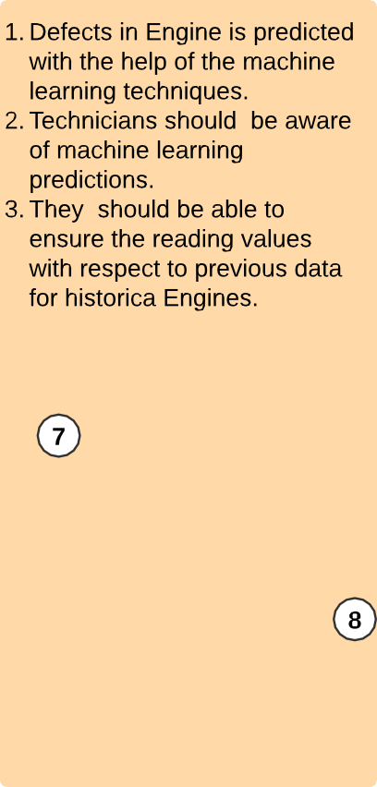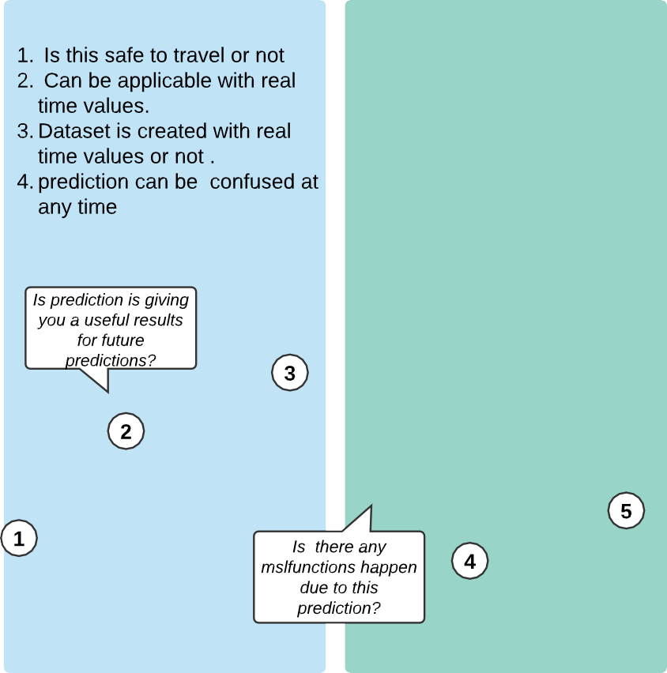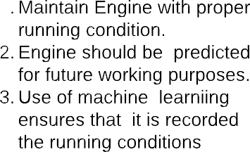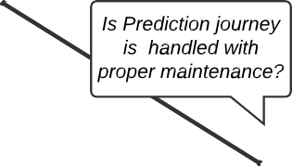

Phase of journey

Phase of journey

CUSTOMER HANDLING

ENGINE & MAINTENANCE